**Security on AWS**

* Trusted Advisor:
  + This AWS service to provide recommendations on cost, performance and security  
    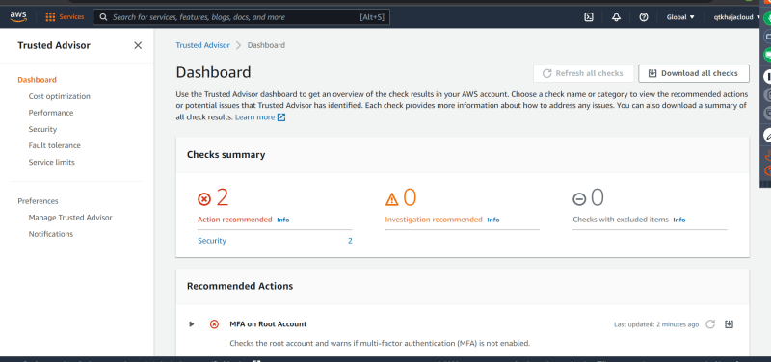
* AWS GaurdDuty  
  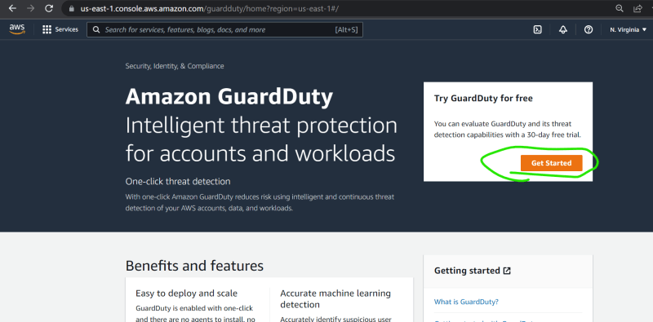  
  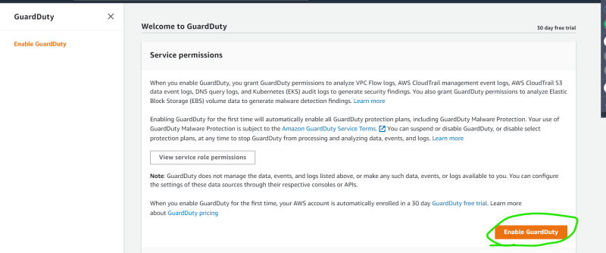  
  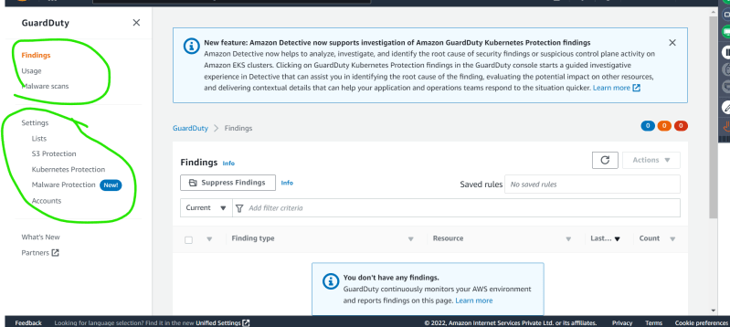
* A small script to access home page continuously

#!/bin/bash

while true

do

curl http://18.212.20.237

done

* Then we can add trusted ip list (Whitelist) and threat ip list (blacklist)
* AWS Macie:
  + This service scans for sensitive content on the S3 buckets
  + PII (Personally Identifiable Information) should not be stored in logs of your application.